2023-2024
Door County
4-H Horse
&
Pony Project
Record Book
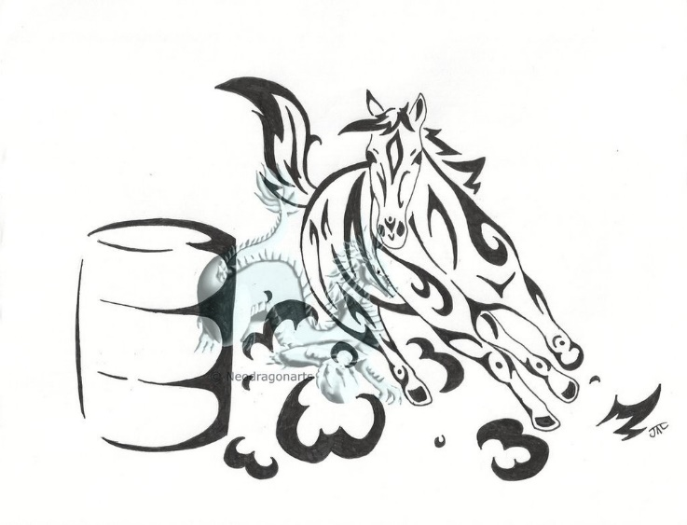
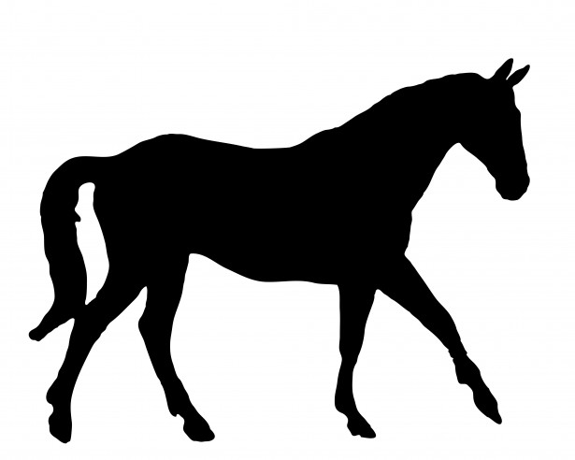

Name _____________________________________________________________________

4-H Club ___________________________________________________________________

Age ____________ Grade ____________ Phone Number _________________________

E-Mail _____________________________________________________________________

Horse's Name ______________________________________________________________

Use one record book for each project animal!
GOAL SETTING

We encourage each of our Project Members to set goals at the beginning of the 4-H year. Goal setting helps you to focus on what you'd like to do, and allows you to develop steps to reach those goals. Your goal should be achievable, but challenging. Record your top 3 goals below and use this sheet to track your achievements from October 1, 2023 to July 15, 2024.

___________________________________________________________________________

____________________________________________________________________________

___________________________________________________________________________

____________________________________________________________________________

___________________________________________________________________________

____________________________________________________________________________

____________________________________________________________________________

____________________________________________________________________________

____________________________________________________________________________

___________________________________________________________________________

____________________________________________________________________________

____________________________________________________________________________

____________________________________________________________________________

____________________________________________________________________________

____________________________________________________________________________

____________________________________________________________________________

____________________________________________________________________________

For example, you could set a goal of having your horse pick up correct leads every time when asked; to get past a shying from flag problems, to walk into the trailer without hesitation. Or, you could set higher goals such as qualifying for State Expo, or placing top ten at Gymkhana. Make sure your goals are within your reach!

DOOR COUNTY 4-H
PROJECT BOOK I.D. SHEET
(Attach a copy of Negative Coggins Test)
One clear, colored photograph of the animal must be attached.

4-H MEMBER INFORMATION Circle one: regular member horseless member

Name _______________________________________________________________________

Address _____________________________________________________________________

Phone Number(s) _____________________________________________________________

E-Mail ______________________________________________________________________

Grade (as of Jan. 1) ________________ 4-H Club ___________________________________

HORSE INFORMATION

Name of Horse ________________________________________________________________

Sex __________ Age _____________ Height in Hands ______________________________

Breed or Type _______________________ Registration # ____________________________
(Attach a copy of registration papers)
Brief Description ______________________________________________________________

Premise ID# _______________________________

Ownership (Circle one): Personally Owned Family Owned Non-Family Owned

If Non-Family owned, list:

Owner’s name __________________________ Phone number ________________________

FEEDING RECORD
March 1 through July 15

 | MARCH | APRIL | MAY | JUNE | JULY 1-15 | TOTAL  USED | TOTAL  COST
Grain / Amount
$ Grain/Month
Bales of Hay/Month
$ Bales of Hay/Month
Cost of Salt &
Additive/Month

A. FEEDING COSTS: $___________

DESCRIPTION OF FEED AND SUPPLEMENTS

Grain: Whole Oats _____ Crimped Oats _____ Crushed Oats _____ Corn _____

Barley _____ Commercial Feed _____ (Give analysis or attach a tag from the bag)

Other (list) _____________________________________________________________

Hay: Alfalfa _____ Timothy _____ Clover _____ Orchard Grass _____

Brome Grass _____ Mixed Hay _____ Other (Give Name) ___________________________

Supplements: Vitamins (What Kind) ________________________________ Corn Oil _____

Salt _____ Wheat Germ Oil _____ Linseed Meal _____ Bran _____ Molasses _____

Other (list) _____________________________________________________________

EQUINE HEALTH RECORD

Owner ______________________________ Name ____________________________________
Address ______________________________ Date Foaled ______ Sex ____ Ht. ____ Wt. ____
City _______________ State ___________ Breed ____________________________________
Zip ______________________________ Dam ________________ Sire ________________
Phone _____________________________ Registration &/or Tattoo #_____________________

VACCINATION HISTORY
October 1, 2023 thru July 15, 2024
DISEASE | DATES OF  BOOSTER |  |  | COST
Encephalomyelitis
Influenza
Rhino pneumonitis
Strangles
PHF
Rabies
Tetanus
Other

B. VACCINATION COSTS $___________

DEWORMING HISTORY
PRODUCT | DATE | COST

C. DEWORMING COSTS $________

Date of
Fecal Exam

October 1, 2023 thru July 15, 2024

DENTAL PROCEDURES
October 1, 2023 thru July 15, 2024

Date |  | Date

D. DENTAL COSTS $____________

SUBTOTAL COSTS (B-D) $____________

HOOF CARE PROCEDURES
October 1, 2023 thru July 15, 2024

Date | Procedure | Cost | Date | Procedure | Cost

E. HOOF CARE COSTS $____________

MEDICAL HISTORY
October 1, 2023 thru July 15, 2024

Date | Symptoms / Diagnosis / Treatment | Cost

F. MEDICAL CARE COSTS $____________

(Add additional sheets, if you need more space.)

Now add everything together:
A. Feeding Costs __________
B. Vaccination Costs __________
C. Deworming Costs __________
D. Dental Costs __________
E. Hoof Care Costs __________
F. Medical Care Costs __________

GRAND TOTAL -- ALL COSTS (A-F) $______________________

TACK AND EQUIPMENT INVENTORY
October 1, 2023 thru July 15, 2024

Check all items owned. Do not overlook such items as combs, brushes, buckets, leads, etc. Indicate the condition of ALL items (excellent, good, fair) and include items purchased or added during this project year.

COST
ARTICLES CONDITION (For items added
OWNED (Ex, Good, Fair) this year)

GENERAL
Halter ________________ _______________
Lead Shank ________________ _______________
Sheet ________________ _______________
Blanket ________________ _______________
Cooler ________________ _______________
Shipping Boots ________________ _______________
Bandages ________________ _______________
Longe Line ________________ _______________
Longe Whip ________________ _______________
Other ________________ _______________

GROOMING
Soft Brush ________________ _______________
Hard Brush ________________ _______________
Curry Comb ________________ _______________
Hoof Pick ________________ _______________
Shedding Blade ________________ _______________
Sweat Scraper ________________ _______________
Sponges ________________ _______________
Scissors ________________ _______________
Clippers ________________ _______________
Buckets ________________ _______________
Water Brush ________________ _______________
Shampoo ________________ _______________
Wash Rags ________________ _______________
Other ________________ _______________

RIDING CLOTHES
Boots ________________ _______________
Stable Boots ________________ _______________
Hats ________________ _______________
Show Outfit ________________ _______________
Chaps ________________ _______________
Other ________________ _______________
________________ _______________
________________ _______________
________________ _______________
________________ _______________
________________ _______________
________________ _______________

COST
ARTICLES CONDITION (For items added
OWNED (Ex, Good, Fair) this year)

TACK ________________ _______________
Saddle ________________ _______________
Saddle Pad/Blanket ________________ _______________
Breast Plate ________________ _______________
Bridle ________________ _______________
Extra Bits ________________ _______________
Harness ________________ _______________
Surcingle ________________ _______________
Leather Punch ________________ _______________
Crop, Whip or Bat ________________ _______________
Bosal ________________ _______________
Bareback Pad ________________ _______________
Spurs ________________ _______________
Stall Guard ________________ _______________
Hay Net ________________ _______________
Saddle Rack ________________ _______________
Tack Box ________________ _______________
Saddle Soap ________________ _______________
Buckets ________________ _______________
Other ________________ _______________

MEDICAL AIDS (Do you have this in your 1st Aid Kit?)
Hoof Conditioner ________________ _______________
Antibacterial Soap ________________ _______________
Antiseptic Salve ________________ _______________
Cotton ________________ _______________
Alcohol ________________ _______________
Liniment ________________ _______________
Colic Medication ________________ _______________
Thermometer ________________ _______________
Fly Repellent ________________ _______________
Other ________________ _______________

BEDDING
Sawdust ________________ _______________
Straw ________________ _______________
Shavings ________________ _______________
Other (Type) ________________ _______________

MISCELLANEOUS
________________ ________________ _______________
________________ ________________ _______________
________________ ________________ _______________

TOTAL EXPENSES _____________

DIARY OF TIME SPENT ON MY 4-H PROJECT & ACTIVITIES
October 1, 2023 thru July 15, 2024

This year, my horse and I participated in the following Door County 4-H Horse & Pony Events:

Clinic:____________________________________

Clinic: ____________________________________

Clinic: ____________________________________

Spring Fun Show

Friday Night Lights

July Prep Day

Junior Fair Pleasure Show

Open Fair Pleasure Show

Junior Fair Gymkhana Show

Fall Fun Show

Fall Trail Ride

Drill Team

In addition, we also attended or participated in these events:

  - ___________________________________________________________________
  - ___________________________________________________________________
  - ___________________________________________________________________
  - ___________________________________________________________________
  - ___________________________________________________________________
  - ___________________________________________________________________
  - ___________________________________________________________________
  - ___________________________________________________________________
  - ___________________________________________________________________
In the space below, please specifically indicate each day, the amount of time and the type of work you did with your project animal. Categories you can use for describing the work include but are not limited to: Grooming, Feeding, Tack Care, General Care, Riding, Training, Meetings and 4-H Project Activities. The time period to be documented is from October 1, 2023 thru July 15, 2024. Use additional pages if necessary. Two pages are provided for your use.

Example:
April 23 - 1 hour grooming, 1/2 hour tack care, 2 hours riding

____________________________________________________________________________________________________________________________________________________________________________________________________________________________________________________________________________________________________________________________________________________________________________________________________________________________________________________________________________________________________________________________________________________________________________________________________________________________________________________________________________________________________________________________________________________________________________________________________________________________________________________________________________________________________________________________________________________________________________________________________________________________________________________________________________________________________________________________________________________________________________________________________________________________________________________________________________________________________________________________________________________________________________________________________________________________________________________________________________________________________________________________________________________________________________________________________________________________________________________________________________________________________________________________________________________________________________________________________________________________________________________________________________________________________________________________________________________________________________________________________________________________________________________________________________________________________________________________________

Diary of Time Spent (continued)

____________________________________________________________________________________________________________________________________________________________________________________________________________________________________________________________________________________________________________________________________________________________________________________________________________________________________________________________________________________________________________________________________________________________________________________________________________________________________________________________________________________________________________________________________________________________________________________________________________________________________________________________________________________________________________________________________________________________________________________________________________________________________________________________________________________________________________________________________________________________________________________________________________________________________________________________________________________________________________________________________________________________________________________________________________________________________________________________________________________________________________________________________________________________________________________________________________________________________________________________________________________________________________________________________________________________________________________________________________________________________________________________________________________________________________________________________________________________________________________________________________________________________________________________________________________________________________________________________________________________________________________________________________________________________________________________________________________________

TOTAL HOURS ______________________

AWARDS RECEIVED THIS YEAR
October 1, 2023 thru July 15, 2024
(Specify 4-H or Open)

________________________________________________________________________________________________________________________________________________________________________________________________________________________________________________________________________________________________________________________________________________________________________________________________________________________________________________________________________________________________________________________________________________________________________________________________________________________________________________________________________________________________________________________________________________________________________________________________________________________________________________________________________________________________________________________________________________________________________________________________________________________________________________________________________________________________________________________________________________________________________________________________________________________________________________________________________________________________________________________________________________________________________________________________________________________________________________________________________________________________________________________________________________________________________________________________________________________________________________________________________________________________________________________________________________________________________________________________________________________________

ACTIVITY STORY
Write about the horse-related activities that you participated in this year. What was the result of your participation? (i.e. What did you learn or earn? What are the most important effects that your 4-H experience has had on you this year?)

________________________________________________________________________________________________________________________________________________________________________________________________________________________________________________________________________________________________________________________________________________________________________________________________________________________________________________________________________________________________________________________________________________________________________________________________________________________________________________________________________________________________________________________________________________________________________________________________________________________________________________________________________________________________________________________________________________________________________________________________________________________________________________________________________________________________________________________________________________________________________________________________________________________________________________________________________________________________________________________________________________________________________________________________________________________________________________________________________________________________________________________________________________________________________________________________________________________________________________________________________________________________________________________________________________________________________________________________________________________________________________________________________________________________________________________________________________________________________________________________________________________________________________________________________________________________________________________________________________________________________________________________________________________________________________________________________________________________________________________________

PARENT / LEADER EVALUATION
A. Parent evaluation of 4-H work and Signature. Discuss what your son/daughter accomplished in this project this year.

_____________________________________________________________________________
_____________________________________________________________________________
_____________________________________________________________________________
_____________________________________________________________________________
_____________________________________________________________________________
_____________________________________________________________________________
_____________________________________________________________________________
Signature ____________________________________________

B. 4-H Club Leader Comments and Signature

_____________________________________________________________________________
_____________________________________________________________________________
_____________________________________________________________________________
_____________________________________________________________________________
_____________________________________________________________________________
_____________________________________________________________________________
Signature ___________________________________________

C. Horse & Pony Project Chair Comments and Signature

_____________________________________________________________________________
_____________________________________________________________________________
_____________________________________________________________________________
_____________________________________________________________________________
_____________________________________________________________________________
_____________________________________________________________________________
Signature __________________________________________

PHOTOGRAPHS
(Do Not Attach Extra Pages)

REQUEST FOR FUNDING

STATE EXPO AND/OR GYMKHANA

Use this form to request funding from the 4-H Horse & Pony Project to help you compete at the State Expo or State Gymkhana competition. Exhibitors must adhere to the following requirements:
- Attend at least two (2) Horse & Pony Project meetings prior to the Fair. College students must attend one (1) meeting prior to the Fair (during the current 4-H year).
- Sixteen (16) hours of HORSE-RELATED volunteer work of your choice at a show, clinic, fair or workday. College students must volunteer eight (8) hours (hours must be recorded on Volunteer Hours-Record Sheet.
- Exhibit their animal at the Fair, and follow all Fair rules.
- Complete and turn in all registration information, funding requests, volunteer hours and Project Record Books on or before August 31, 2024 to the Extension Office.
- Our website https://doorcounty4hhorseandpony.webs.com/

A special meeting may be held for those who need to turn in forms, funding requests, volunteer hours and record books.
Members will...
- turn in completed Expo and/or Gymkhana forms
- turn in completed Volunteer Hours-Record Sheet
- turn in completed Record Books

  - Funding is available to those riders who participate by showing their animal in the Expo, Gymkhana, Dressage or State Fair (funding will be issued after the events).
- Record Books are available at http://doorcounty4hhorseandpony.webs.com/ or
http://door.uwex.edu/4-h-youth-development/

I am requesting funding for the following:

State Gymkhana State Dressage
4-H State Horse Expo State Fair

Name _____________________________________________________________________
4-H Club _____________________________________________________________________
Address _____________________________________________________________________
_____________________________________________________________________
Phone _______________________________ E-Mail _______________________________

Signature _____________________________________________________________________

Date __________________________

DOOR COUNTY 4-H HORSE & PONY PROJECT
VOLUNTEER HOURS – INDIVIDUAL RECORD SHEET
OCTOBER 1, 2023 through AUGUST 13, 2024

Note: Deadline for submitting hours is August 31, 2024

Name _______________________________________________________________________

Address _____________________________________________________________________

Phone Number(s) _____________________________________________________________

E-Mail ______________________________________________________________________

4-H Club _____________________________________________________________________

- Sixteen (16) total hours of HORSE RELATED volunteer work of your choice at a show, clinic, fair, or workday; college students must volunteer eight (8) hours; of these required volunteer hours, twelve (12) hours [six (6) hours if a college student] must be at a 4-H EVENT such as shows, clinics, fair, or workdays.

- An ADULT will need to initial the activity; if there is any question, the adult may be contacted for verification purposes.

DATE | ACTIVITY | TIME | ADULT INITIALS

TOTAL HOURS ____________

DOOR COUNTY 4-H
PROJECT BOOK I.D. SHEET
(Attach a copy of Negative Coggins Test and Premise ID number)
One clear, colored photograph of the animal must be attached.

4-H MEMBER INFORMATION Circle one: regular member horseless member

Name ______________________________________________________________________

Address ____________________________________________________________________

Phone Number(s) ____________________________________________________________

E-Mail _____________________________________________________________________

Grade (as of Jan. 1) ___________ 4-H Club ______________________________________

HORSE INFORMATION

Name of Horse _______________________________________________________________

Sex ____________ Age ______________ Height in Hands __________________________

Breed or Type _____________________ Registration # _____________________________
(Attach a copy of registration papers)
Brief Description ______________________________________________________________

Premise ID# ____________________________________

Ownership (Circle one): Personally Owned Family Owned Non-Family Owned

If Non-Family owned, list:

Owner’s name __________________________ Phone number _______________________

THIS SHEET MUST BE TURNED INTO THE EXTENSION OFFICE BY JULY 1st.

